**TASK ON KAFKA TOPIC**

Kafka is a streaming platform has three key capabilities:-

* Publish and subscribe to streams of records, similar to a message queue or enterprise messaging system.
* Store streams of records in a fault-tolerant durable way.
* Process streams of records as they occur.

**DOWNLOAD THE CODE:-**

Take one terminal and download the code

We suggest the following mirror site for your download:

<http://mirrors.estointernet.in/apache/kafka/2.1.0/kafka_2.11-2.1.0.tgz>

$wget <http://mirrors.estointernet.in/apache/kafka/2.1.0/kafka_2.11-2.1.0.tgz>

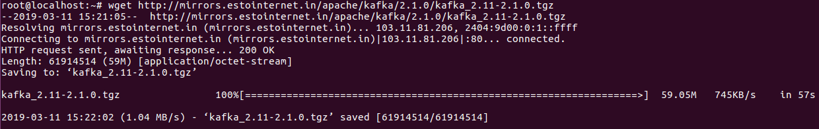

And now extract the file here

$tar -xzf kafka_2.11-2.1.0.tgz



And move to that folder

$cd kafka_2.11-2.1.0



**NOW START THE SERVER**

Kafka usesZookeeper so you need to first start a ZooKeeper server

$bin/zookeeper-server-start.sh config/zookeeper.properties

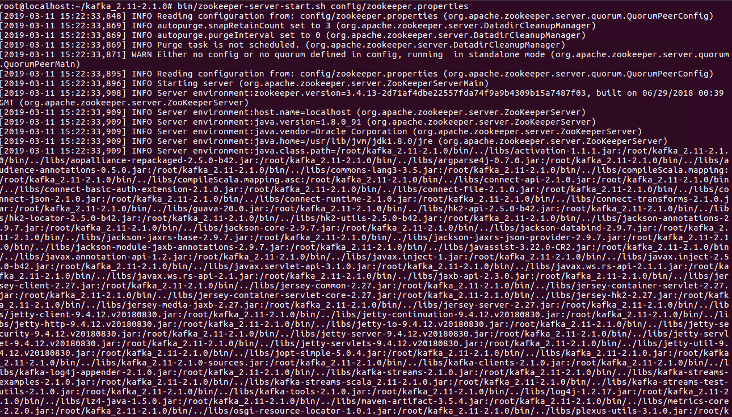

**Now start the Kafka server:**

$bin/kafka-server-start.sh config/server.properties

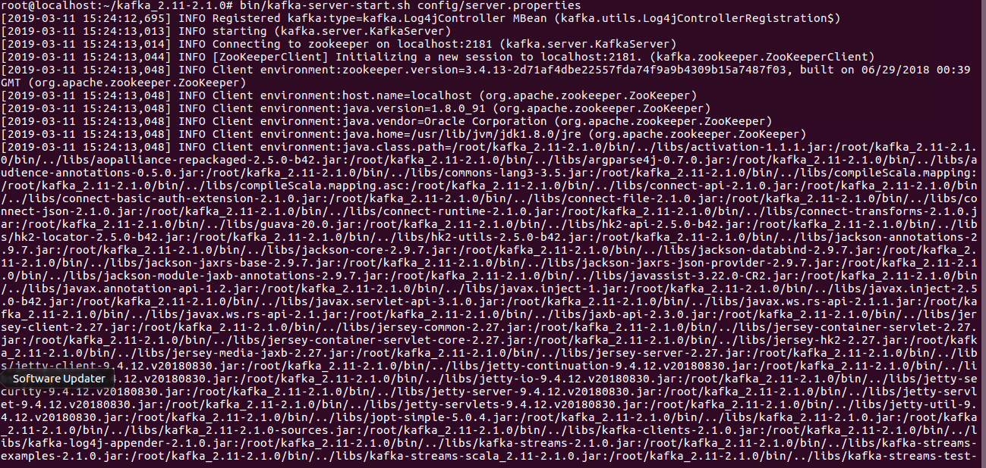

**NOW CREATAE THE TOPIC**

Let's create a topic named "aadhya" with 5 partition and only 1 replica

$bin/kafka-topics.sh --create --zookeeper localhost:2181 --replication-factor 1 --partitions 5 --topic test



Listing all topics in a cluster

$bin/kafka-topics.sh --list --zookeeper localhost:2181

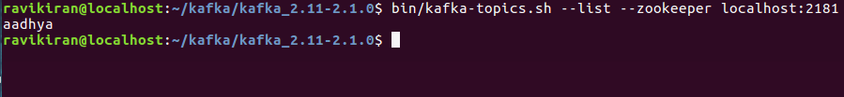

Now Describing test Topic details

$bin/kafka-topics.sh --zookeeper localhost:2181 --describe --topic aadhya

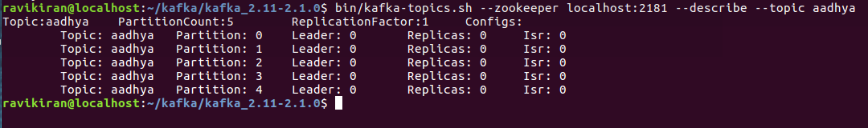

Take one new terminal and Run the producer and then type a few messages into the console to send to the server.

$bin/kafka-console-producer.sh --broker-list localhost:9092 --topic aadhya



Kafka also has a command line consumer that will dump out messages to standard output.

$bin/kafka-console-consumer.sh --bootstrap-server localhost:9092 --topic aadhya --from-beginning



Now Adding Partitions for an existing topic:-

Adding Partitions for an existing topic test

$./bin/kafka-topics.sh --alter --zookeeper localhost:2181 --topic aadhya --partitions 7



Now describe the topic

Check the partitions list for conformation

$bin/kafka-topics.sh --zookeeper localhost:2181 --describe --topic aadhya

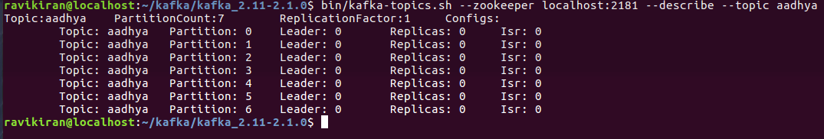

Now gotot producer terminal

Produce messages file for the same above topic(data needed to send from a file, but not from console)

$bin/kafka-console-producer.sh --broker-list localhost:9092 --topic aadhya <raju



Now goto consumer terminal

Check the details of file sending messages

$bin/kafka-console-consumer.sh --bootstrap-server localhost:9092 --topic aadhya --from-beginning



**Delete a topic**

We want to delete the topic

$bin/kafka-topics.sh --zookeeper localhost:2181 --delete --topic aadhya

